# Project Design Phase-I Solution Architecture

|  |  |
| --- | --- |
| Date | 19 September 2022 |
| Team ID | IBM-Project-PNT2022TMID43472 |
| Project Name | IoT Based Safety Gadget for Child Safety  Monitoring & Notification |
| Maximum Marks | 4 Marks |

**TEAM MEMBERS:**

M.Nivetha

M.Rishnika

D.Prem

K.Samyuktha prithyankara

**Solution Architecture:**

Solution architecture is a complex process – with many sub-processes – that bridges the gap between business problems and technology solutions. Its goals are to:

* Find the best tech solution to solve existing business problems.
* Describe the structure, characteristics, behavior, and other aspects of the software to project stakeholders.
* Define features, development phases, and solution requirements.
* Provide specifications according to which the solution is defined, managed, and delivered.

# Solution Architecture Diagram:

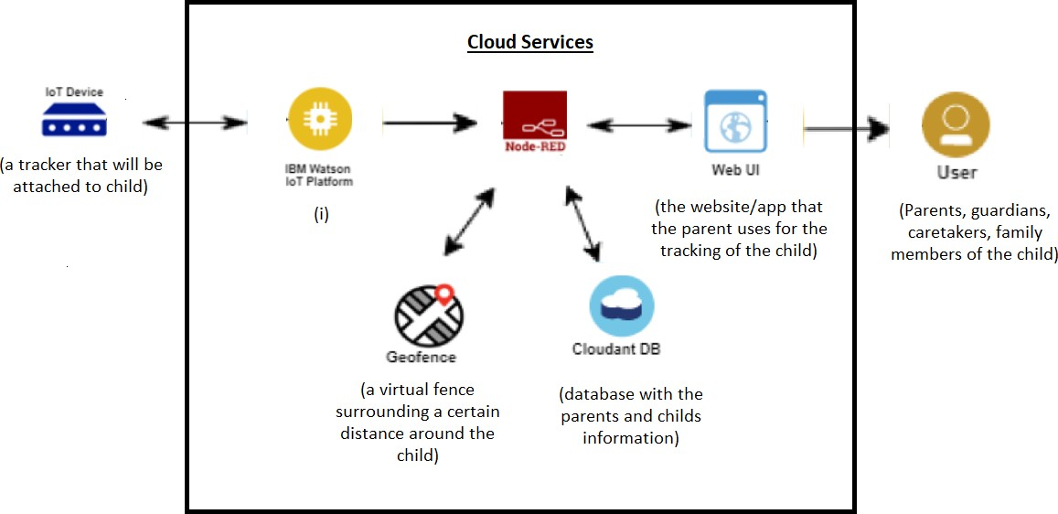

*Figure 1: Architecture and data ﬂow of the application*

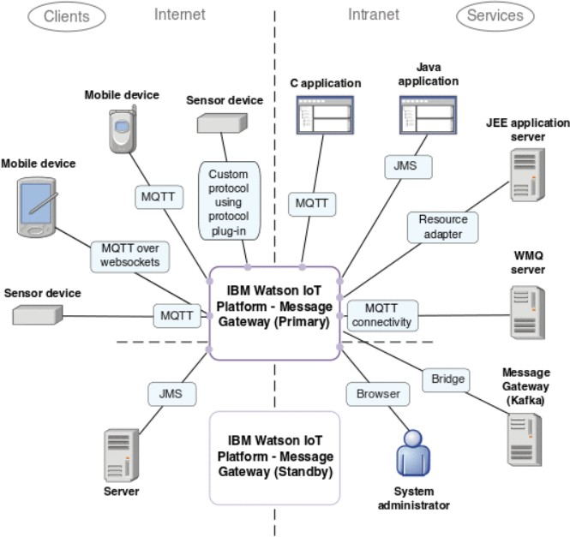*Figure 2: Architecture of the IBM Watson IoT Platform*